|  |  |
| --- | --- |
|  | **PURPOSE:** The purpose of this Policy is to describe the manner in which Behavioral Center of MI & Samaritan Behavioral Center identify and provide financial assistance to uninsured patients and to patients who need help paying their hospital bills. This Policy refers to these hospitals collectively as the "Hospitals," and individually as a "Hospital." This Policy is intended to satisfy the requirements in Section 501(r) of the Internal Revenue Code of 1986, as amended, which imposes certain requirements on the Hospitals regarding financial assistance, charge limitations, and billing and collection activities. Patients who do not have the means to pay for services provided at the Hospitals may request financial assistance, and may be awarded financial assistance, in accordance with the terms and conditions of this Policy. This Policy is also intended to satisfy certain Medicare hospital cost reporting rules. All providers at the hospitals are included in the financial assistance policy. |

# II. POLICY:

It is the policy of the hospitals to provide financial assistance for in patient mental health services and other Medically Necessary Care to individuals who qualify for such assistance under this Policy; Not charge patients eligible for financial assistance under this Policy for Emergency Care or other Medically Necessary Care more than the Amounts Generally Billed (i.e., Hospitals will not charge a patient who is eligible for financial assistance under this Policy for In Patient or other Medically Necessary Care more than the Gross Charges for such care multiplied by the amounts generally billed (AGB) Percentage); and Charge patients eligible for financial assistance under this Policy less than Gross Charges.

**III. DEFINITIONS: A.** Amounts Generally Billed or AGB: Each Hospital will apply the "look-back method" for determining AGB. Each hospital will determine the Amounts Generally Billed for all medical are by multiplying the Gross Charges for that care by the AGB Percentage. The following definitions apply for purposes of this Policy. **B**. AGB Percentage: Each Hospital will calculate its own AGB Percentage by dividing the sum of all claims that have been allowed for all medical care by Medicare fee-for-service and all private health insurers together during a prior twelve (12)-month period by the sum of the associated Gross Charges for those claims. For these purposes, included in the amount "allowed" is both the amount to be reimbursed by Medicare or the private insurer and the amount (if any) the Medicare beneficiary or insured individual is personally responsible for paying (in the form of co- insurance, copayments or deductibles), regardless of whether and when the individual actually pays all or any of his or her portion, and disregarding any charity care adjustments or discounts applied to the individual's portion (under this Policy or otherwise). Each Hospital will calculate a revised AGB Percentage annually and will apply the revised AGB Percentage by the 120thday after the end of the 12 month-period used to determine the AGB Percentage. **C**. Family: Using the U.S. Census Bureau definition, a group of two or more people who reside together and who are related by birth, marriage, or adoption. In addition, if the patient is claimed as a dependent on a parent's or adult child's tax return, the party claiming the patient as a dependent will be considered a member of the patient's Family. **D.** Family Assets: The combined assets (other than Family Income) of the patient, members of the patient's Family and all Guarantors, as adjusted in accordance with this Policy. Family Assets include, without limitation, monies held in bank accounts and investment accounts, bonds, certificates of deposit, and trust assets. Excluded from Family Assets are real property; vehicles; and assets jointly owned by the patient and an individual who is not a member of the Family, but only if the patient's access to the asset is solely for the benefit of the non-Family member. Applicants for financial assistance may be required to provide documentation regarding the value of Family Assets. **E.** Family Income: Total income received by the patient, the patient's Family members who are older than 15 years of age, and all Guarantors from all sources, including, for example, earnings, unemployment compensation, workers' compensation, Social Security, Supplemental Security Income, public assistance, veterans' payments, survivor benefits, pension or retirement income, interest, dividends, rents, royalties, income from trusts, educational assistance, alimony, child support, and other assistance. For this purpose, retirement accounts will be valued based on their annuity value, with the annual equivalent value treated as Family Income; twenty-five years will be used as the duration of the annuity, and 3.5% will be used as the annual growth rate. During the presumptive eligibility screening process, Hospital may estimate a patient's Family Income by using a third-party-developed calculation model, which utilizes credit report information, self-reported data, marketing data sources and average incomes for others near the patient's reported address. **F**. Gross Charges: The Hospital's full established rates for the provision of healthcare items and services. **G**. Guarantor: A person other than the patient who is responsible for payment of the patient's medical bills. **H**. Medically Necessary Care: Those services reasonable and necessary to diagnose and provide preventive or restorative treatment for physical or mental conditions in accordance with professionally recognized standards of healthcare generally accepted at the time services are provided. **I**. Uninsured Patient: An individual having no third-party coverage by a commercial insurer, ERISA plan, a federal healthcare program (including, without limitation, Medicare, Medicaid, SCHIP and CHAMPUS), worker's compensation, or other third-party assistance to assist with meeting his or her financial obligations for medical care.

**IV. PROCEDURE:** A. Hospital staff responsible for scheduling appointments or admissions should refer all patients without insurance and unable to pay for care to a billing specialist to determine eligibility for financial assistance. Patients with insurance who cannot afford to pay their share of the total amount due should also be referred to a billing specialist. B. Eligibility for Charity Care Adjustment 1. Eligibility Criteria a. Eligibility for financial assistance in the form of a charity care adjustment is based on the patient's demonstrated inability to pay for services or items due to inadequate financial resources. A patient is not eligible for financial assistance in the form of a charity care adjustment under this Policy if the patient's Family Assets are valued at $50,000 or more, regardless of the patient's Family Income. b. A patient with Family Assets valued at less than $50,000 who satisfies the following criteria will qualify for financial assistance in the form of a charity care adjustment of amounts owed for IP Mental Health or other Medically Necessary Care by the patient (but not on amounts owed by a third-party payor), based on a sliding scale, in the amount indicated. Financial assistance is generally determined by your total household income as compared to the Federal Poverty Level. If your income is less than or equal to 250% of the Federal Poverty Level, you may receive a 100% charity care write-off on the portion of the charges for which you are responsible. If your income is above 250% of the Federal Poverty Level but does not exceed 400% of the Federal Poverty Level, you may receive discounted rates on a sliding scale. If you have medical debt for emergency and medically necessary care that exceeds your income, you may be eligible for a discount. If you have assets in excess of 250% of your Federal Poverty Level income amount you may not qualify for financial assistance. Patients who are eligible for financial assistance will not be charged more for eligible care than the amounts generally billed to patients with insurance coverage. For coverage effective in 2025, 250% of the federal poverty level in the continental U.S. will be**$37,650** for a single individual, $64,550 for a family of three, and $104,900 for a family of six. d. If the patient is claimed as a dependent on a parent's or adult child's tax return, the income of the party claiming the patient as a dependent, along with any other Family Income, will be considered as the basis for determining eligibility. e. If current Family Income has significantly increased over the past year, Hospital may suspend a decision regarding financial assistance in the form of a charity care adjustment if there is a reasonable basis to believe that Family Income will revert back to previous levels. Notwithstanding any provision of this Policy to the contrary, if Family Income has significantly decreased over the past year, hospital may deny financial assistance in the form of a charity care adjustment if there is a reasonable basis to believe that Family Income will revert back to previous levels within the next year. f. Financial assistance is not applicable to an insurance company's or benefit plan's payment responsibility under a health benefits plan, regardless of whether the insurance company or health plan has made payment to the patient or to hospital. g. If the patient receives a financial settlement or judgment from a third-party tortfeasor that caused the patient's injury that led to the medical services and items provided by hospital, the patient must use the settlement or judgment amount to satisfy any patient account balances and will not be eligible for financial assistance in the form of a charity care adjustment. h. In addition to meeting the Family Income and Family Assets criteria set forth above, to be eligible for financial assistance in the form of a charity care adjustment under this Policy, a patient also must: ▪ Complete the Financial Assistance Application provided by hospital; ▪ Supply all documentation requested by hospital in accordance with this Policy and the Financial Assistance Application form; ▪ Apply for all public assistance programs requested by the hospital, including, for example, Medicaid, Social Security, disability, etc.; and ▪ Cooperate with hospital in determining whether or not the patient is eligible for financial assistance under this Policy. i. hospital will provide reasonable assistance to patients in pursuit of public benefits for which they may qualify (such as, for example, Michigan Medicaid). A patient who is a Medicaid beneficiary will be deemed presumptively to qualify for 100% financial assistance in the form of a charity care adjustment. If a patient is presumptively determined to be eligible for 100% financial assistance in the form of a charity care adjustment, the Business Office will notify the patient of the determination in writing, and the patient will not be required to complete a Financial Assistance Application. Proof of Family Income and Family Assets a. All applicants for financial assistance in the form of a charity care adjustment should provide proof of Family Income and Family Assets. Upon request of hospital, an applicant may be required to provide copies of the following that are applicable: ▪ Paycheck stubs for at least the last four weeks or a statement from the employer verifying gross wages ▪ IRS Forms W-2 issued during the past year ▪ Most recent IRS Form 1040 ▪ Most recent two months of bank statements for each checking, savings, money market or other bank or investment account ▪ Written statements for the most recent two months for all other income (e.g., unemployment compensation, disability, retirement, etc.) ▪ Unemployment compensation denial letter ▪ Documentation of Family Assets values b. Failure to provide any of these documents may result in a denial of financial assistance, although an applicant will not be denied financial assistance based on failure to provide information or documentation that this Policy or the Financial Assistance Application does not explicitly require. If an applicant does not have any of the listed documents to demonstrate Family Income or Family Assets, the applicant may contact the Hospital's billing department.

The completed Financial Assistance Application should be submitted, along with the required supporting documentation, to Behavioral Center of Michigan 4050 E. 12 Mile Rd. Warren, MI 48092 – ATTN: Billing Department Telephone: (586)261-2166

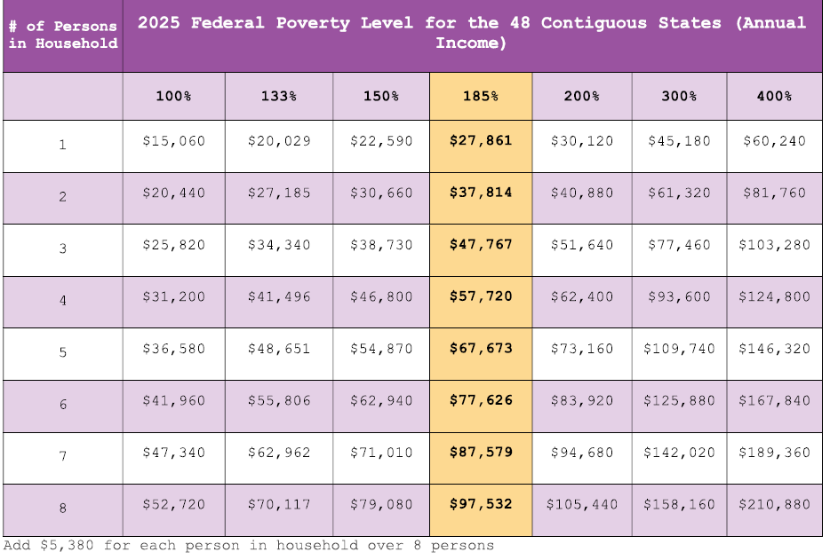

|  |  |
| --- | --- |
| **Next Review Date:** | 5/2026 |
| **Review Date:** |  |
| **Revision Date:** | 1/2025 |
| **Revision History:** |  |
| **Key Word Search:** | Financial Assistance |

This policy is:  New  Reviewed  Revised